**Εργασία Δίκτυα Υπολογιστών ΙΙ –**

**Wireshark Screenshots**



Ονοματεπώνυμο: Μιχαήλ Καρατζάς

ΑΕΜ: 9137

email: [mikalaki@ece.auth.gr](mailto:mikalaki@ece.auth.gr)

Εξάμηνο : 9ο

Δεδομένα και κώδικες της εργασίας [εδώ](https://www.dropbox.com/sh/qyausy4cjhnd5z7/AABS6NhRMhpr8YUmXQ4En1Aja?dl=0)

Στο παρόν αρχείο παρατίθενται το σύνολο των screenshot από το εργαλείο Wireshark, που ζητήθηκαν στα πλαίσια εκπόνησης της εργασίας.

1. **Session 1 Wireshark screenshots:**

* **Session 1 Codes and attributes**

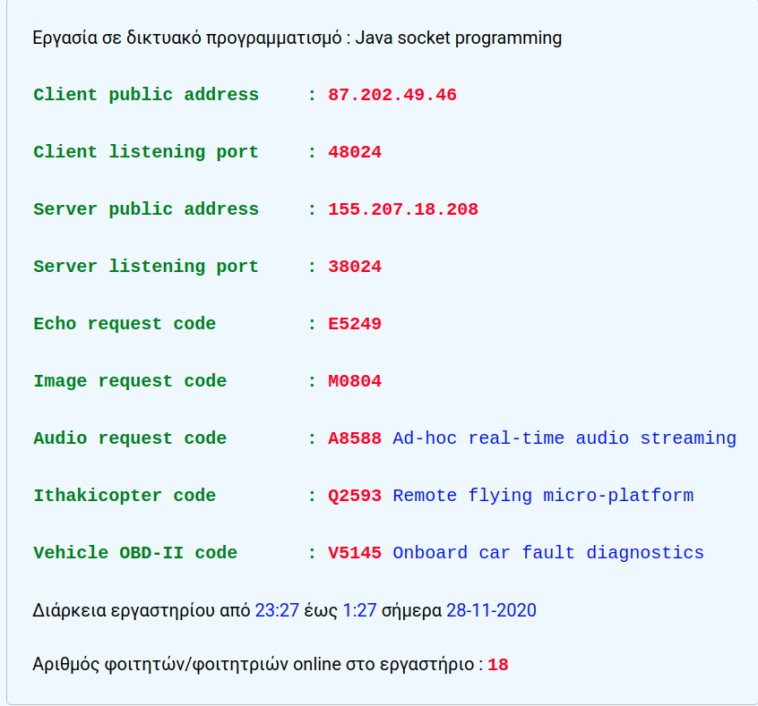

* **Echo request Packet before Image application (before Image 1 download) (Session 1):**

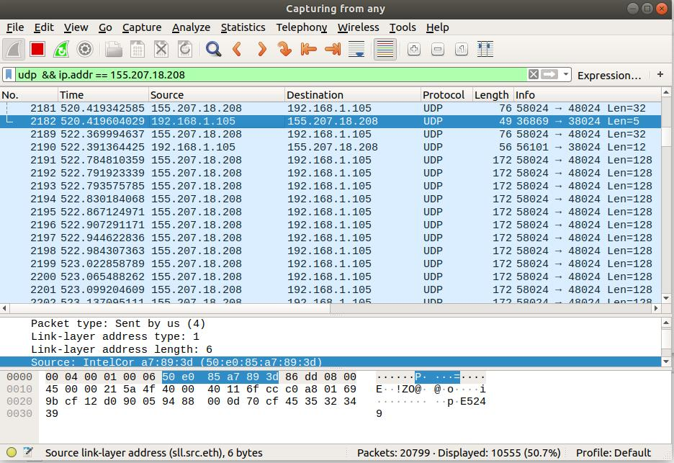  
EeeEcho request Packet before Image application

* **Echo response Packet from server, before Image application (before Image 1 download) (Session 1):**

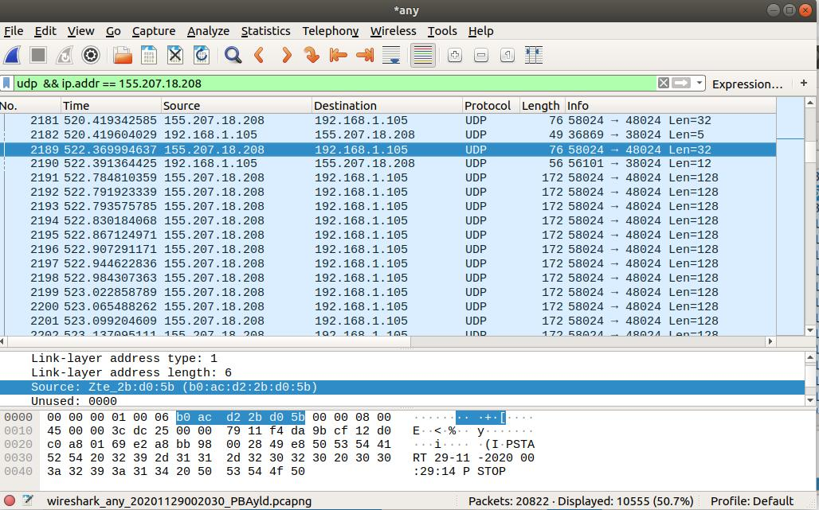  
Echo response Packet before Image application

* **Image request Packet (for Image 1) (Session 1):**

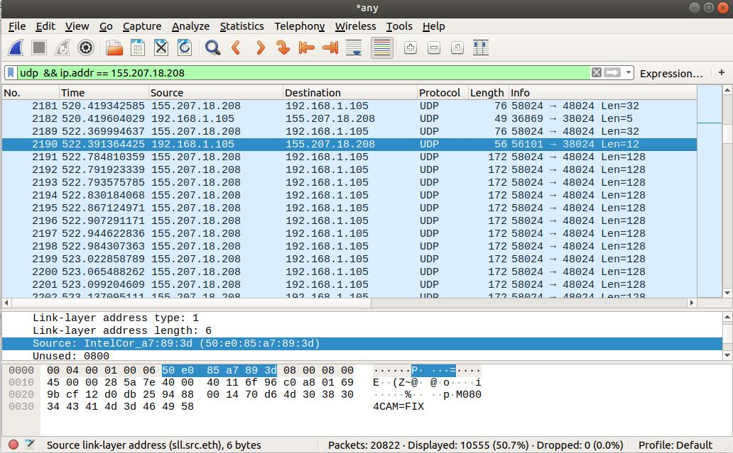  
Image request Packet

* **Image 1st response Packet from server (Image 1) (Session 1):**

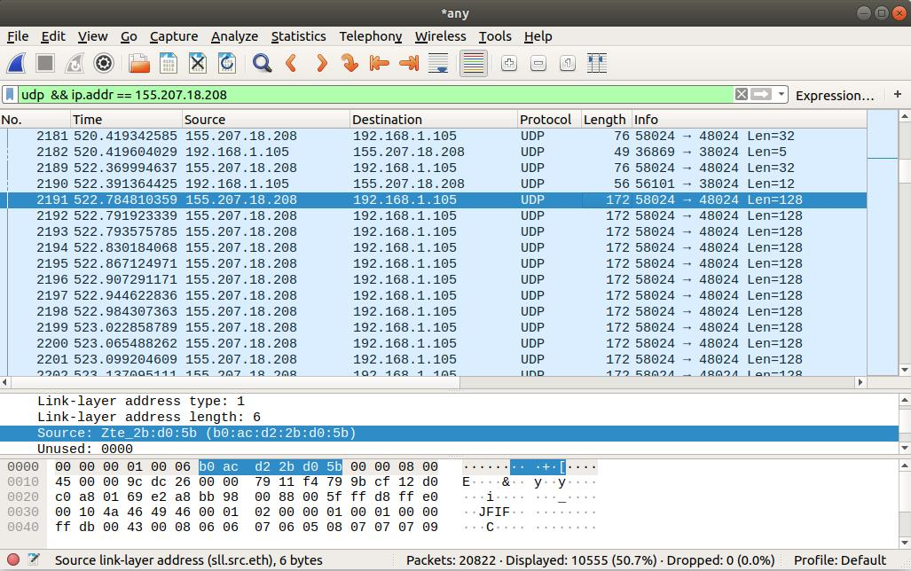  
Image 1st response Packet *from server*

* **Echo request Packet before DPCM sound application (before frequency generator sample) (Session 1):**

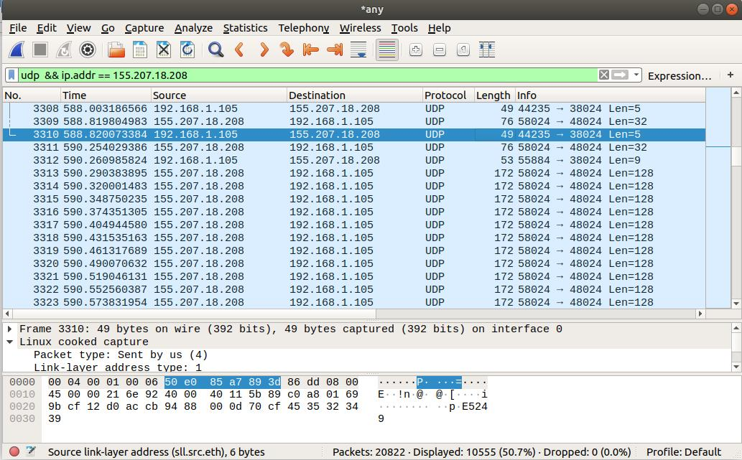  
Echo request Packet before DPCM sound application

* **Echo response Packet from server, before DPCM sound application (before frequency generator sample) (Session 1):**

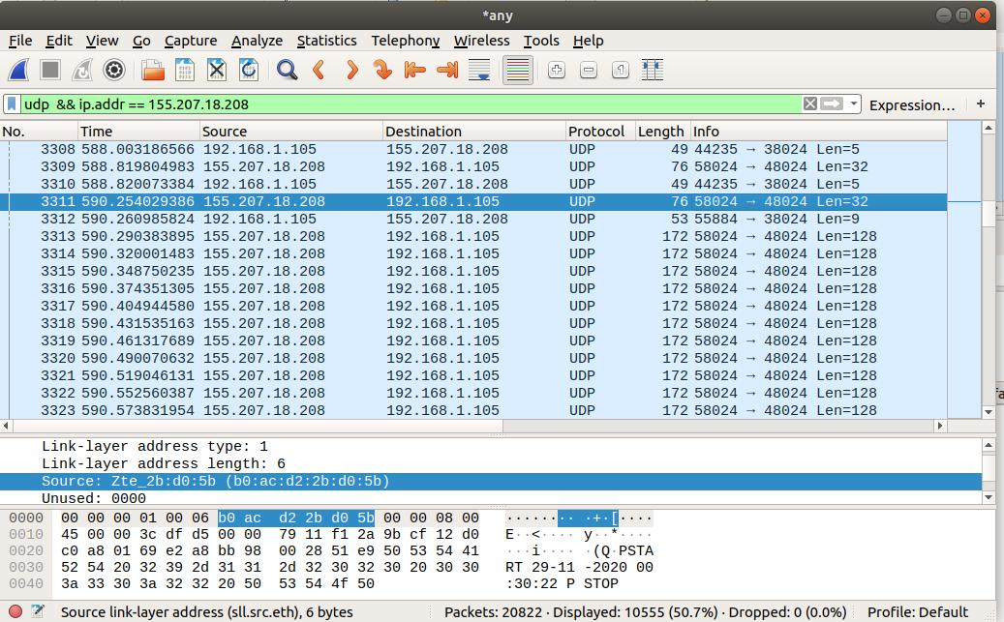  
Echo response from server Packet before DPCM sound application

* **DPCM sample request Packet (frequency generator sample request) (Session 1):**

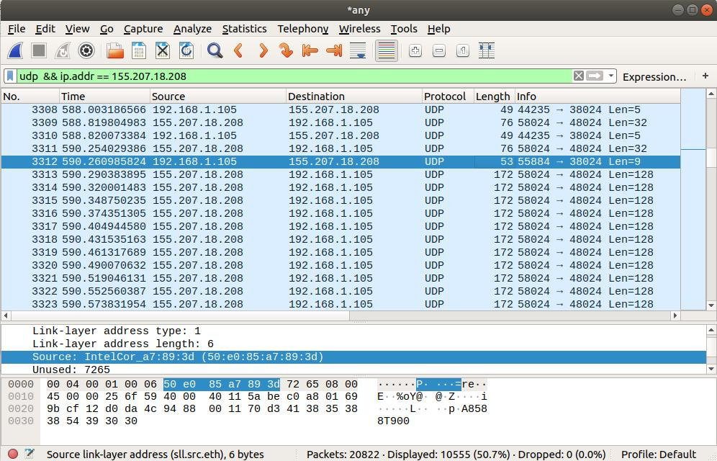  
DPCM sample request Packet

* **DPCM sample first response Packet from server(frequency generator sample request) (Session 1):**

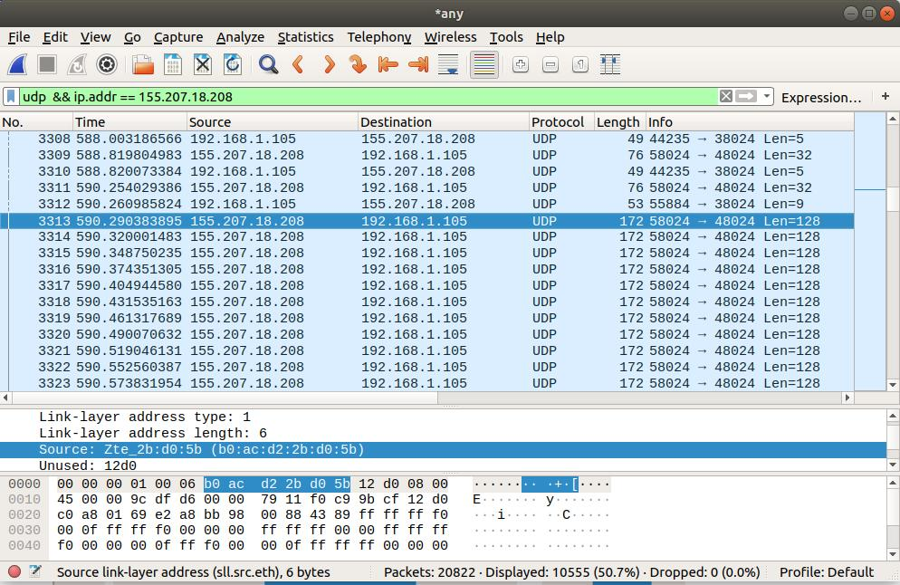  
DPCM sample first response Packet from server

* **Echo request Packet before IthakiCopter application (Session 1):**

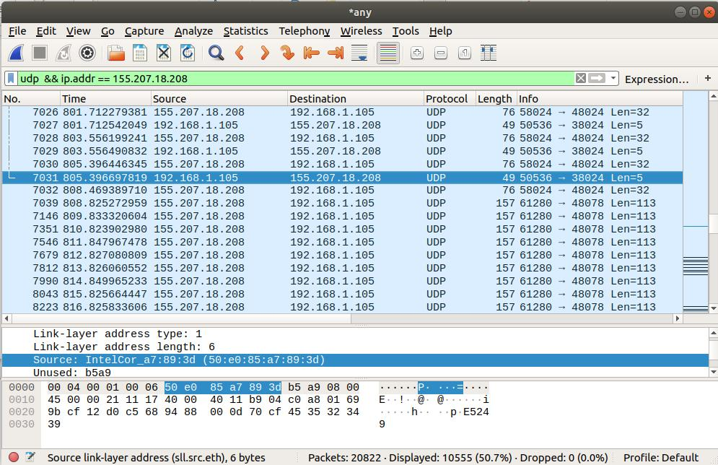  
Echo request Packet before IthakiCopter application

* **Echo response Packet from server, before IthakiCopter application (Session 1):**

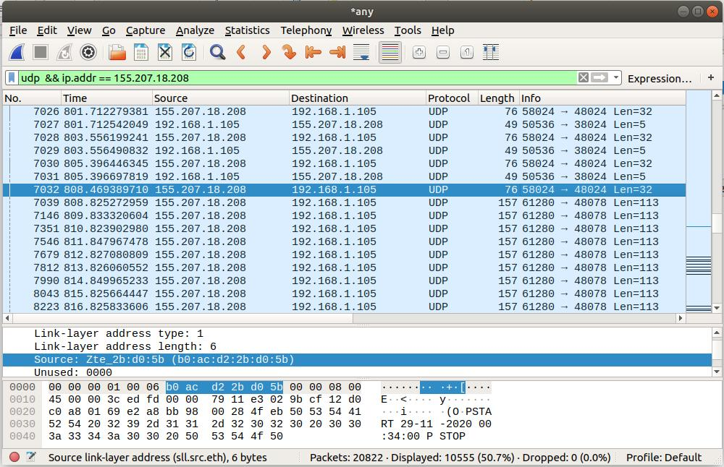  
Echo response Packet from server, before IthakiCopter application

(We don’t have Ithakicopter requests as we used the JAR application of Ithaki Copter)

* **Ithakicopter’s 1st response Packet (Session 1):**

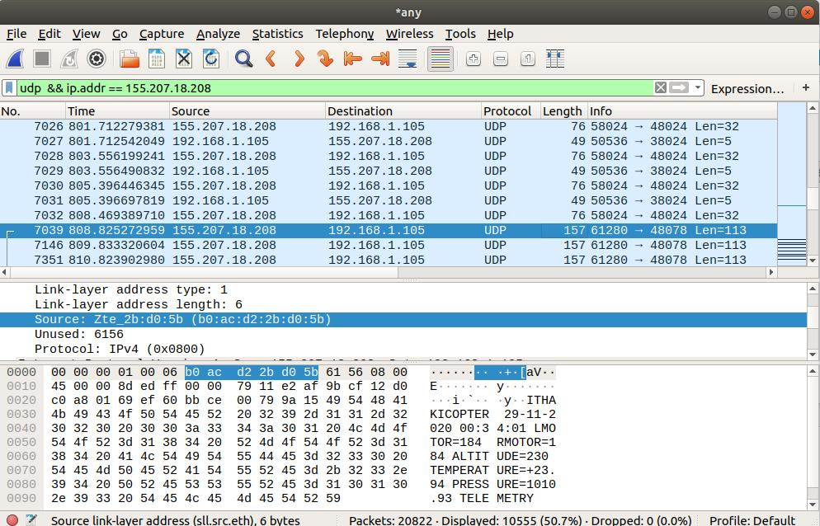  
Ithakicopter’s 1st response Packet

* **Echo request Packet before ODB-II diagnostics application (Session 1):**

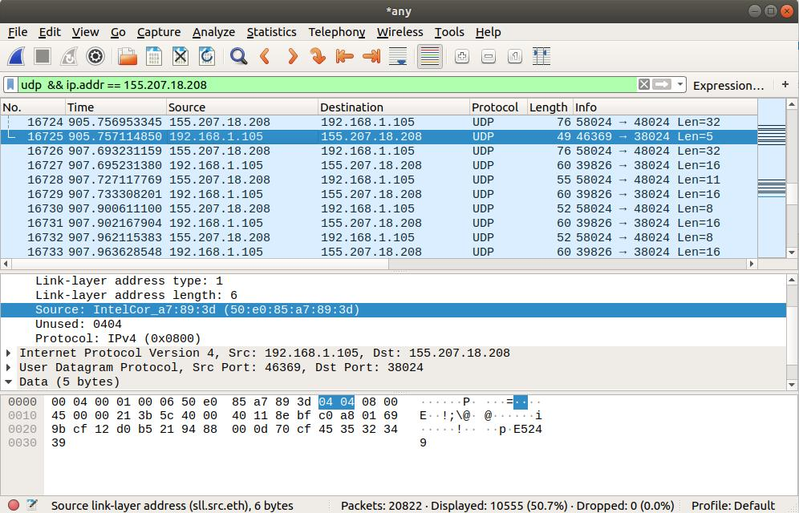  
Echo request Packet before ODB-II diagnostics application

* **Echo response Packet from server, before ODB-II diagnostics application (Session 1):**

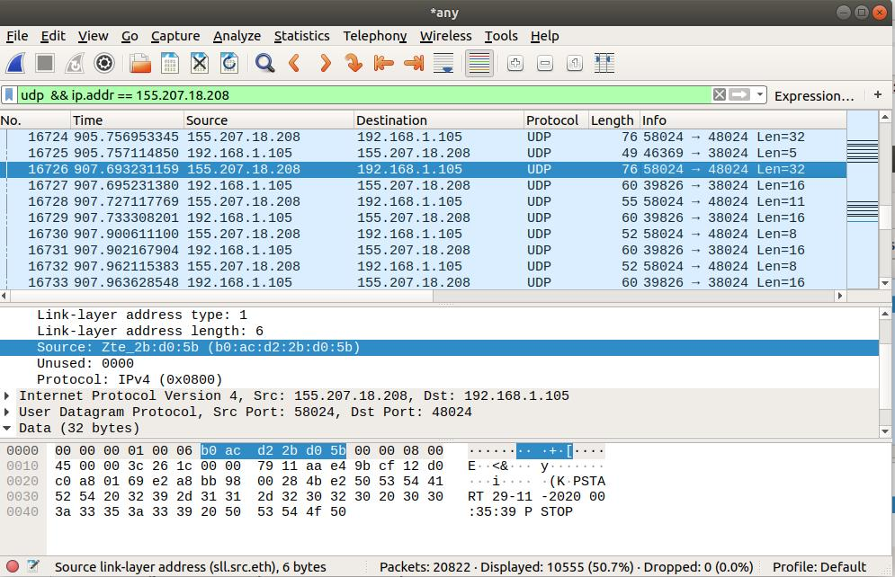  
Echo response Packet from server, before ODB-II diagnostics application

* **ODB-II diagnostics request Packet (Engine Runtime Request) (Session 1):**

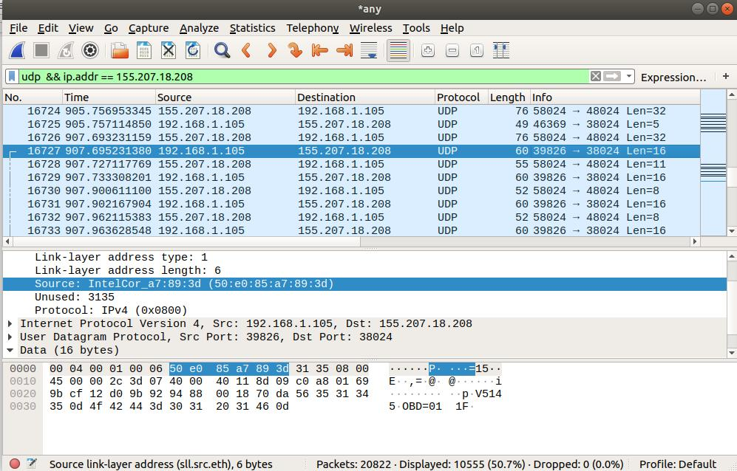  
ODB-II diagnostics request Packet (Engine Runtime Request)

* **ODB-II diagnostics response Packet (Engine Runtime Response) (Session 1):**

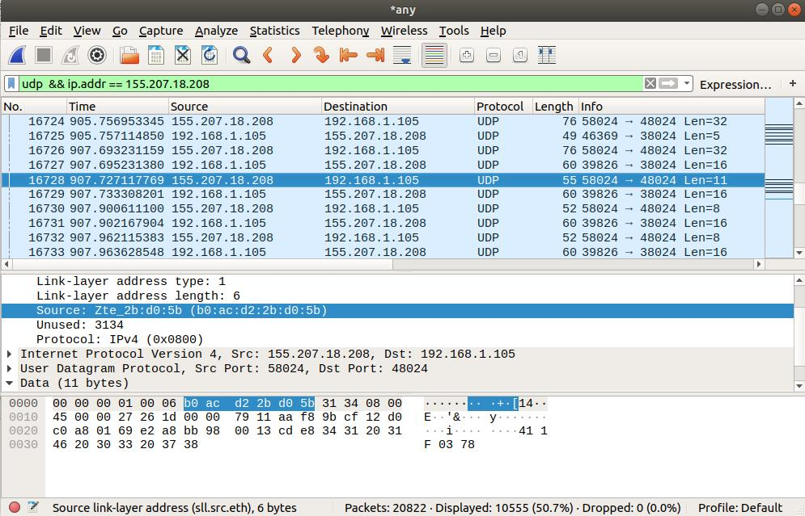  
ODB-II diagnostics response Packe t (Engine Runtime Response)

1. **Session 2 Wireshark screenshots:**

* **Session 2 Codes and attributes**

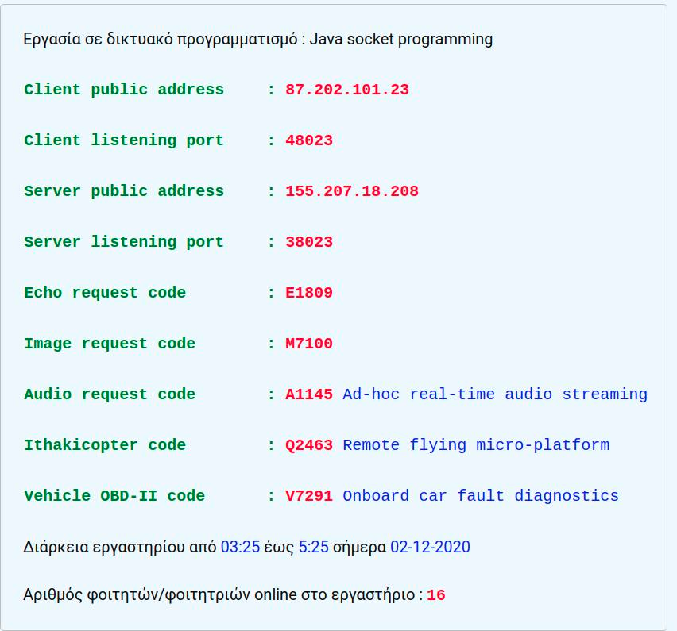

* **Echo request Packet before Image application (before Image 1 download) (Session 2):**

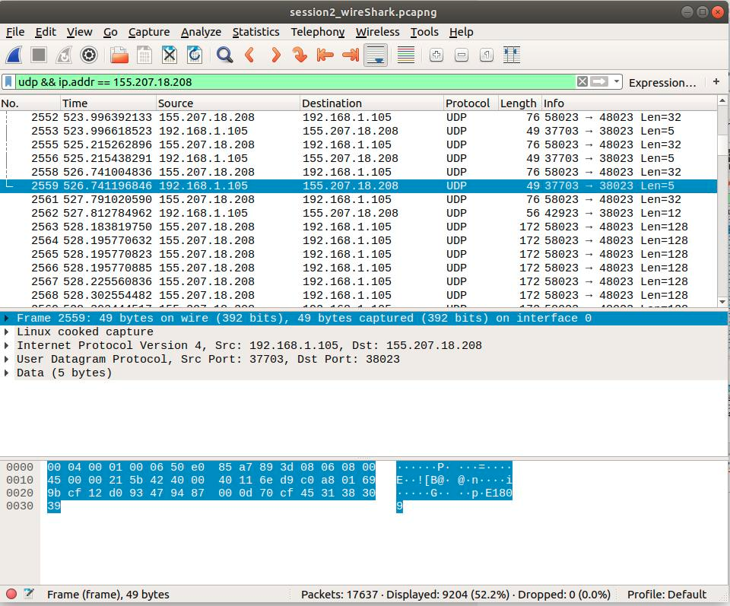  
EeeEcho request Packet before Image application

* **Echo response Packet from server, before Image application (before Image 1 download) (Session 2):**

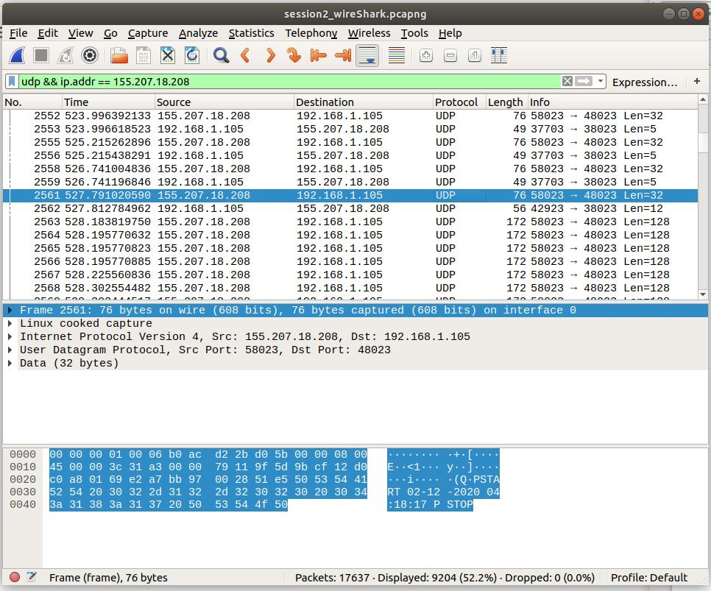  
EEeeEcho response Packet from server, before Image application

* **Image request Packet (for Image 1) (Session 2):**

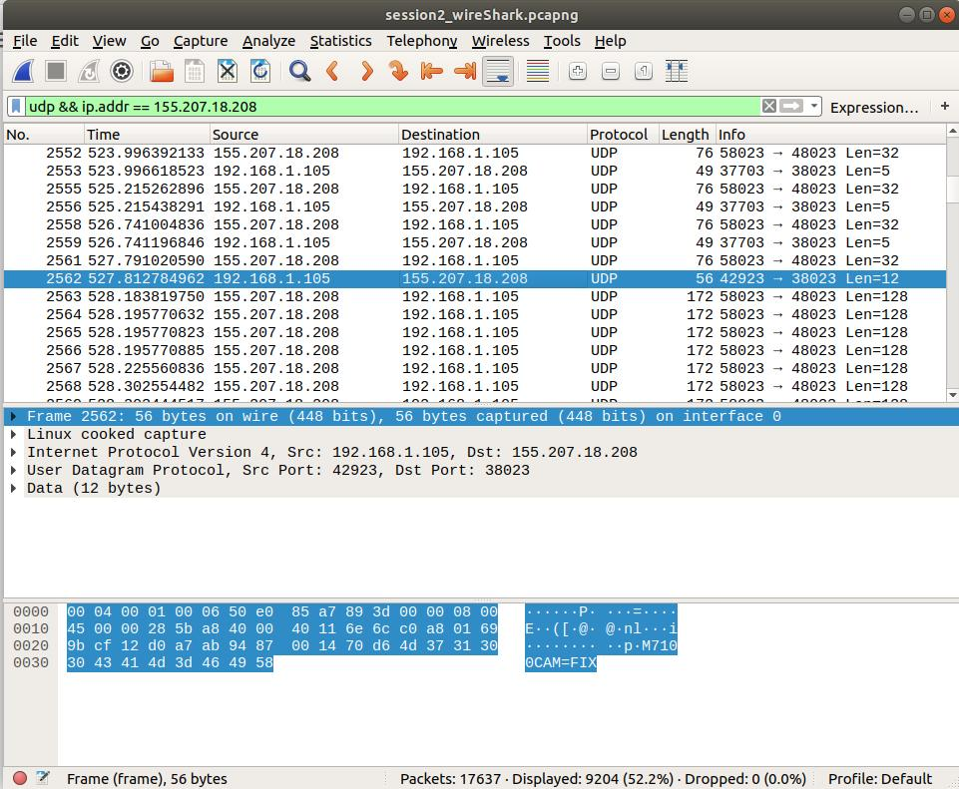  
Image request Packet

* **Image 1st response Packet from server (Image 1) (Session 2):**

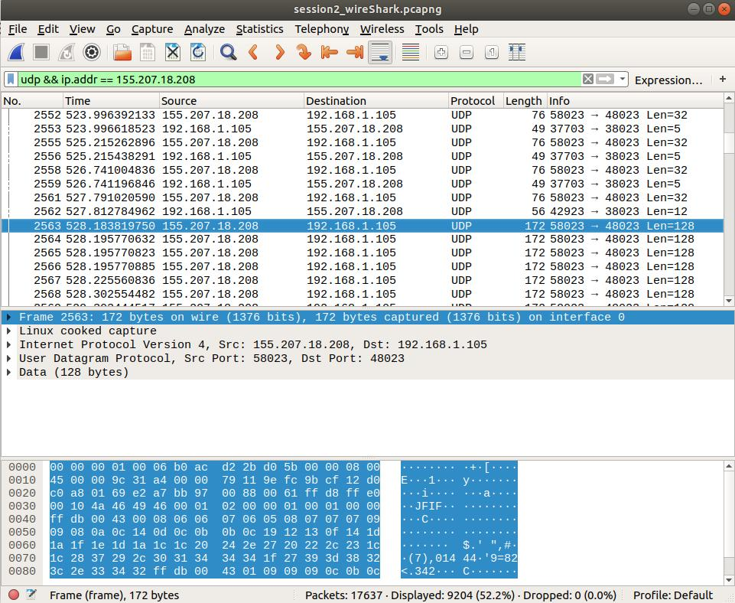  
Image 1st response Packet from server

* **Echo request Packet before DPCM sound application (before frequency generator sample) (Session 2):**

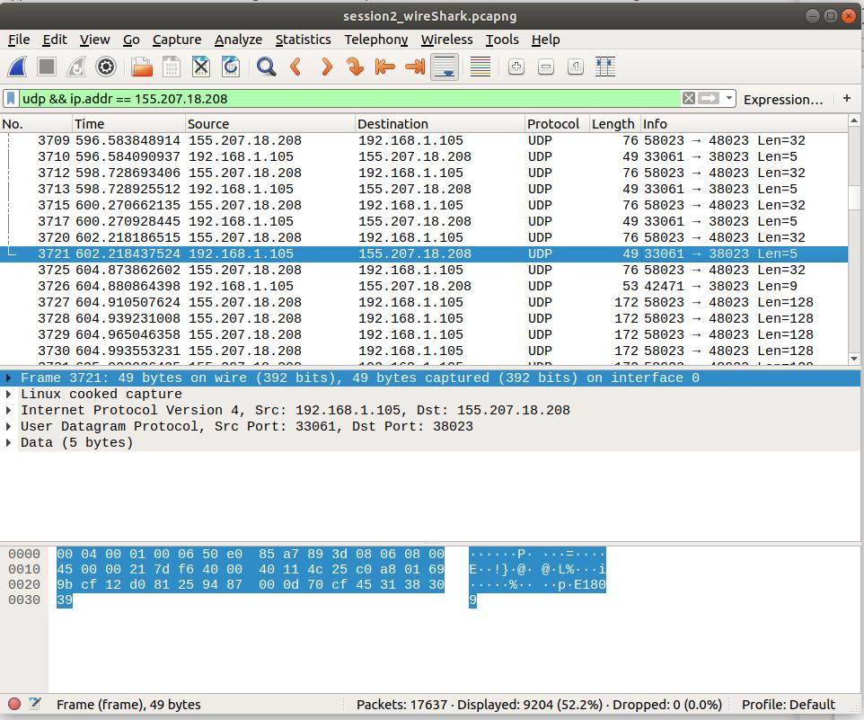  
Echo request Packet before DPCM sound application

* **Echo response Packet from server, before DPCM sound application (before frequency generator sample) (Session 2):**

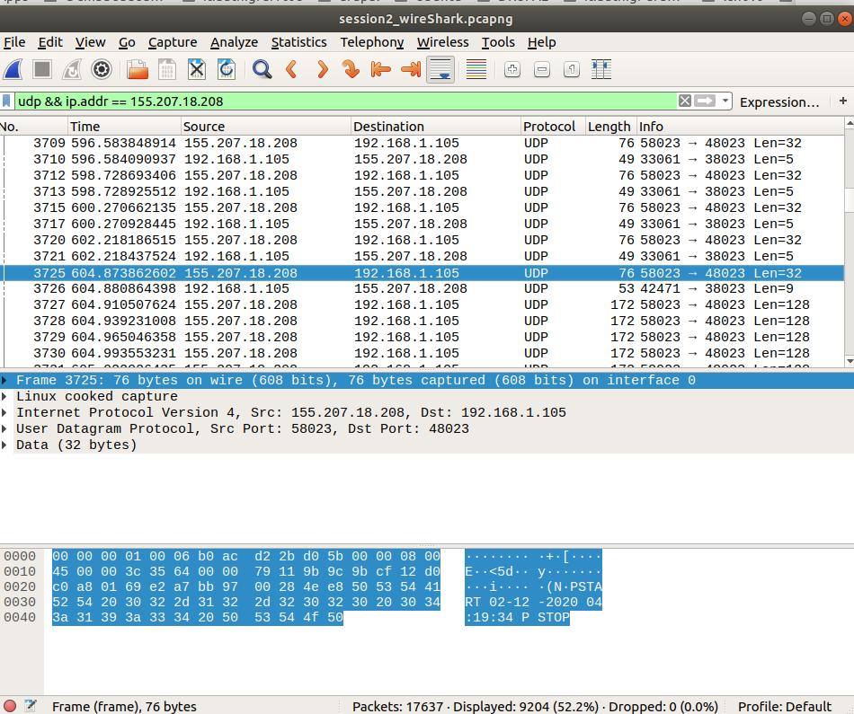  
Echo response Packet from server, before DPCM sound application

* **DPCM sample request Packet (frequency generator sample request) (Session 2):**

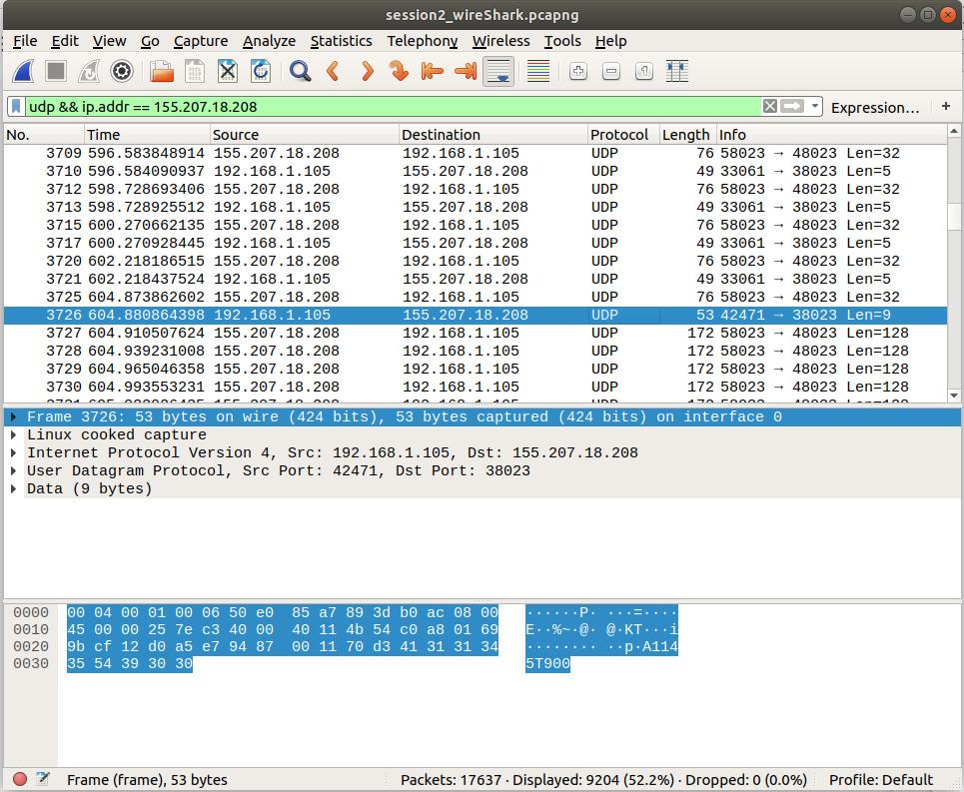  
DPCM sample request Packet

* **DPCM sample first response Packet from server(frequency generator sample request) (Session 2):**

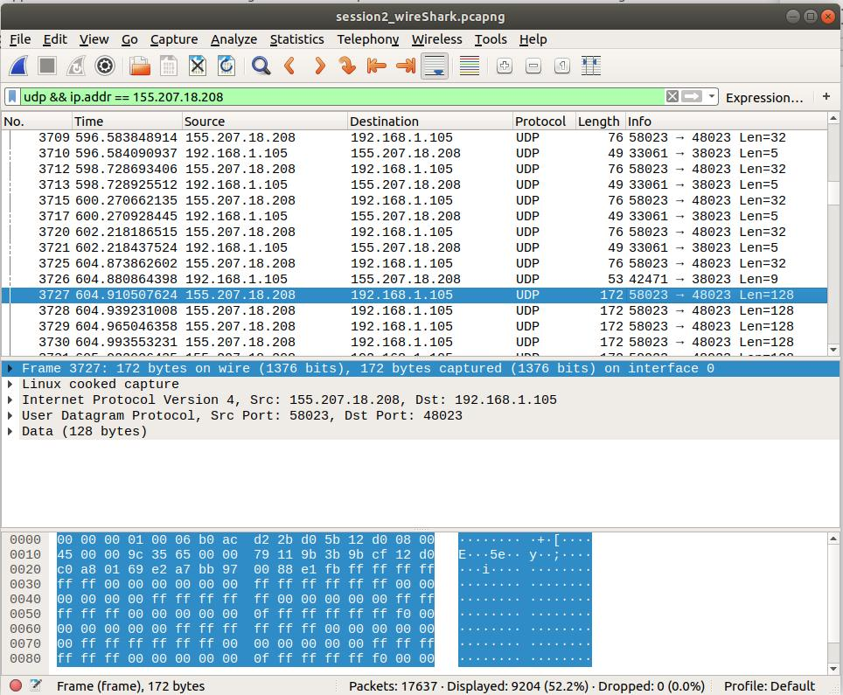  
DPCM sample first response Packet from server

* **Echo request Packet before IthakiCopter application (Session 2):**

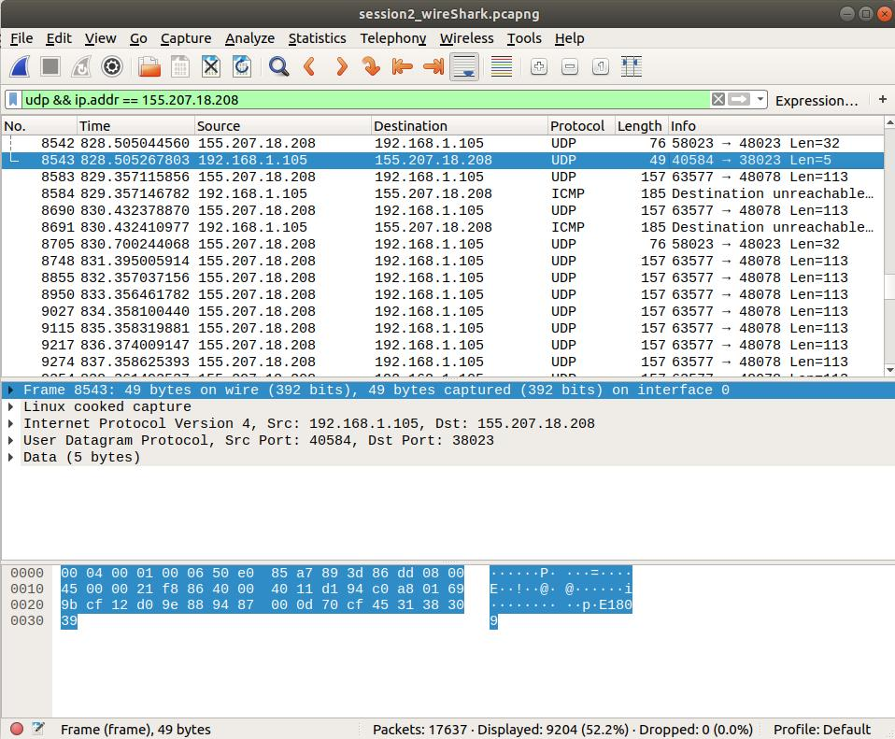  
Echo request Packet before IthakiCopter application

Βλέπουμε ότι κατά τα screenshot που έχουν να κάνουν με την εφαρμογή IthakiCopter κατά το session 2 έχουμε και πακέτα τύπου ICMP, οποία από ότι φαίνεται έχουν κανουν με την εφαρμογή ithakicopter.jar, που εκίνησε λίγο πριν την ενάρξη της λήψης των μετρήσεων telemetry. Κατά την εκίνηση του ithakicopter.jar το copter ήταν εν κίνηση, ενδεχομένως εξαιτίας της τηλέδιαχείρισης του copter από κάποιο συνάδελφο .

* **Echo response Packet from server, before IthakiCopter application (Session 2):**

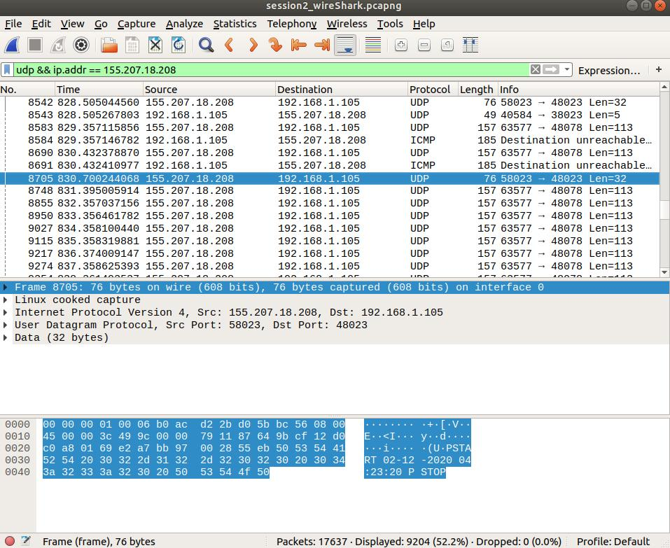  
Echo response Packet from server, before IthakiCopter application

(We don’t have Ithakicopter requests as we used the JAR application of Ithaki Copter)

* **Ithakicopter’s 1st response Packet (Session 2):**

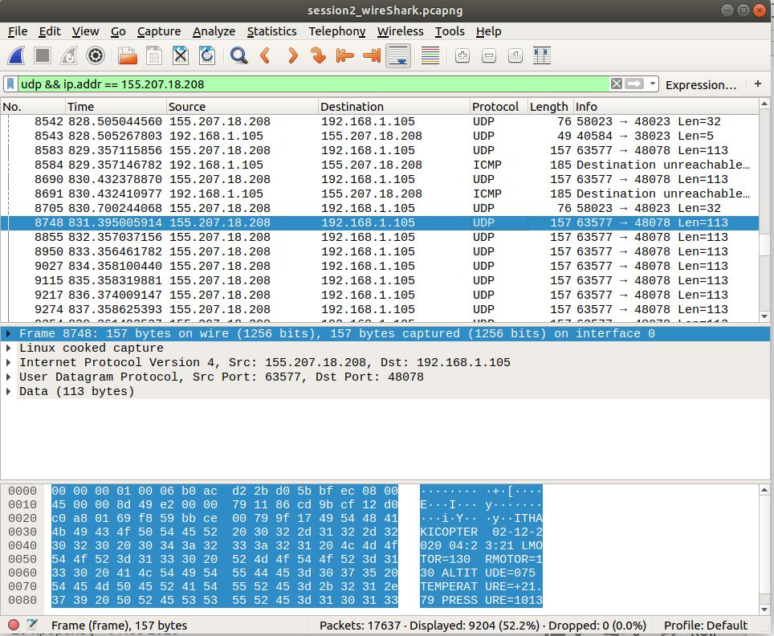  
Ithakicopter’s 1st response Packet

* **Echo request Packet before ODB-II diagnostics application (Session 2):**

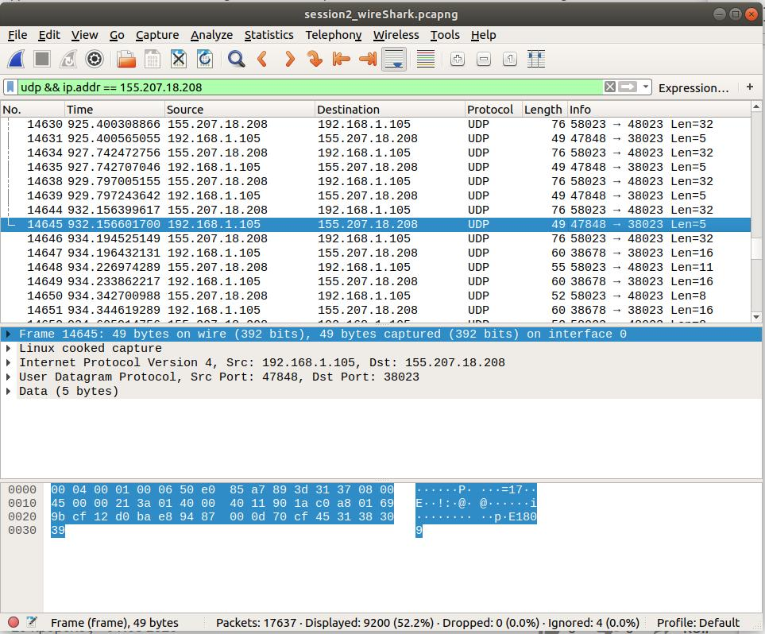  
Echo request Packet before ODB-II diagnostics application

* **Echo response Packet from server, before ODB-II diagnostics application (Session 2):**

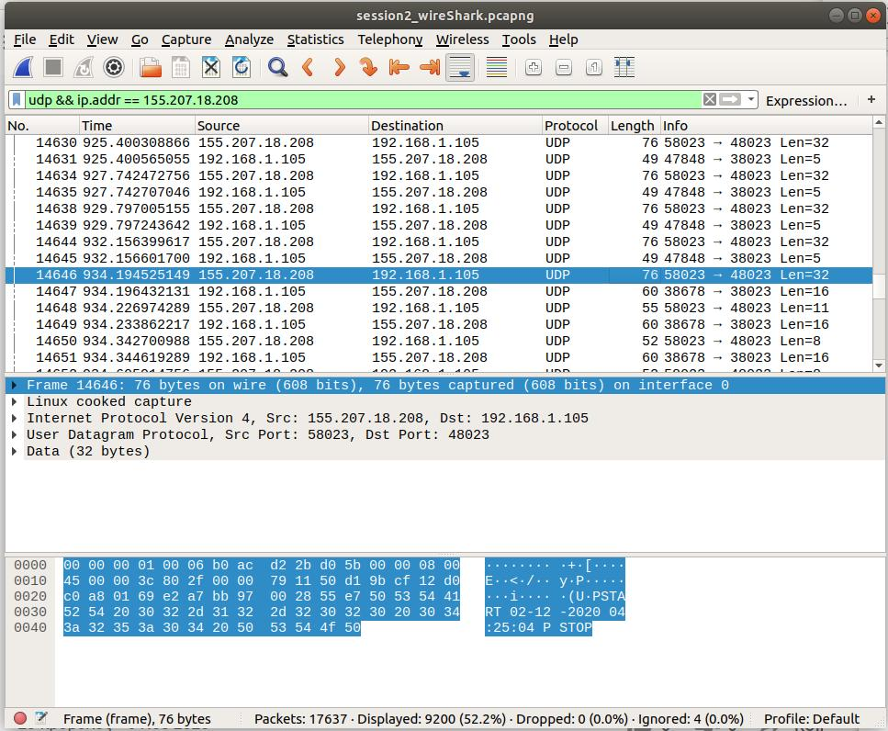  
Echo response Packet from server, before ODB-II diagnostics application

* **ODB-II diagnostics request Packet (Engine Runtime Request) (Session 2):**

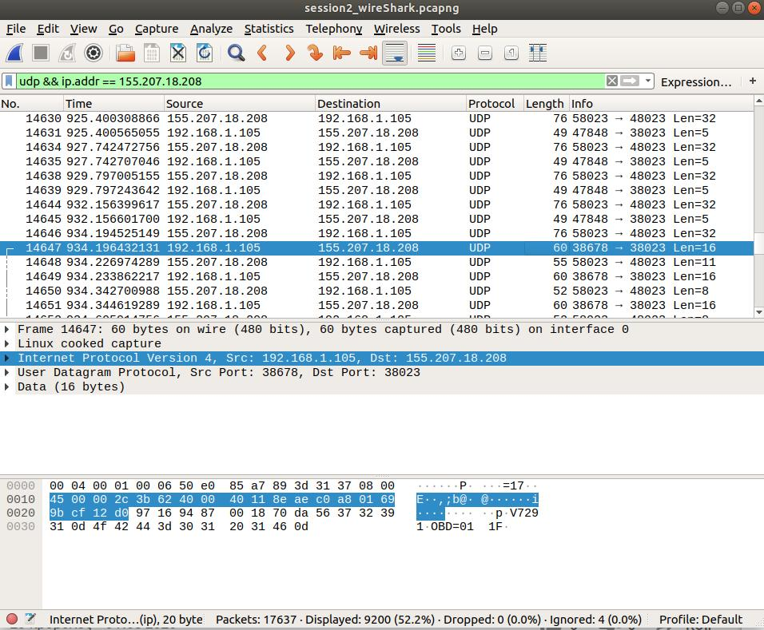  
ODB-II diagnostics request Packet (Engine Runtime Request)

* **ODB-II diagnostics response Packet (Engine Runtime Response) (Session 2):**

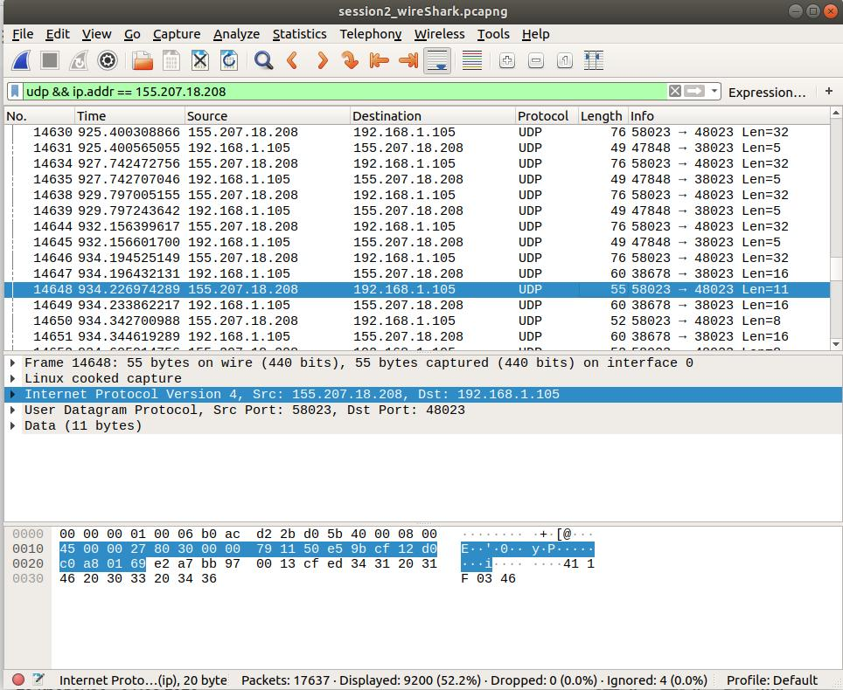  
ODB-II diagnostics response Packet (Engine Runtime Response)